1)Why Cloud is Better than Maintaining Servers
Maintaining your own servers (on-premises) requires high cost, space, and technical effort. Cloud computing improves this:
- Cost-effective: No need to buy expensive hardware or data centers
- Scalable: Increase or decrease resources anytime
- Less maintenance: Providers like Amazon Web Services and Microsoft Azure manage hardware and updates
- High reliability: Data is stored in multiple locations, reducing failure risk
- Remote access: Access from anywhere via internet
- Backup & recovery: Easier disaster recovery compared to local servers
Example:
A company hosting its website on local servers may face downtime if hardware fails. On cloud platforms, backup servers automatically take over.

2.What is Cloud Computing
Cloud computing is the delivery of computing services like servers, storage, databases, networking, and software over the internet instead of using local machines.
You don’t own the infrastructure—you rent it from providers like Google Cloud Platform.
Example:
Saving files on Google Drive instead of storing them only on your computer.

Overview of Cloud Computing
Key Characteristics
- On-demand self-service: Use resources whenever needed
- Scalability: Increase/decrease resources
- Pay-as-you-go: Pay only for usage
- Broad network access: Available via internet

3.Types of Cloud Computing
1. Service Models
IaaS (Infrastructure as a Service)
Provides basic computing infrastructure like virtual machines, storage, and networks.
Example:
Using Amazon Web Services EC2 to run virtual servers.

2.PaaS (Platform as a Service) – AWS Examples
PaaS provides a platform where developers can build, run, and manage applications without handling servers.
Examples on Amazon Web Services:
- AWS Elastic Beanstalk
  - Automatically deploys and manages applications
  - Handles scaling, load balancing, and monitoring
  - Example: Upload your code, and it runs your web app without server setup
- AWS Lambda (serverless, often considered PaaS-like)
  - Run code without managing servers
  - Example: Automatically process uploaded images
- AWS App Runner
  - Deploy web applications and APIs quickly
  - Example: Run a backend service without infrastructure management

3.SaaS (Software as a Service) – AWS Examples
SaaS provides ready-to-use software over the internet.
Examples from/related to Amazon Web Services:
- Amazon WorkDocs
  - Document storage and sharing (like Google Drive)
  - Example: Teams collaborate on files online
- Amazon Chime
  - Online meetings and communication
  - Example: Video calls and team collaboration
- Amazon QuickSight
  - Data visualization and analytics
  - Example: Create dashboards from company data
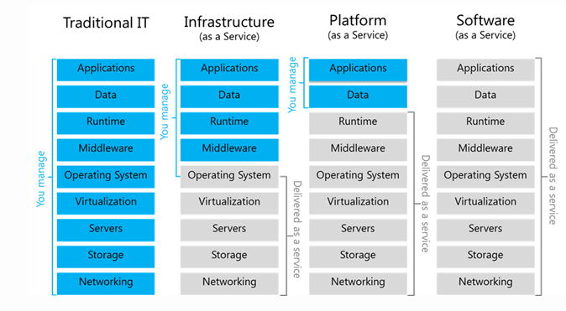

4. Deployment Models
Public Cloud
Cloud services are available to everyone over the internet.
Example:
Services offered by Amazon Web Services.

Private Cloud
Cloud infrastructure is used by only one organization.
Example:
A bank using its own private cloud to store sensitive customer data.

Hybrid Cloud
Combination of public and private cloud.
Example:
A company storing sensitive data in a private cloud but running apps on Microsoft Azure.

Benefits of Cloud Computing
- Cost savings
- Flexibility and scalability
- Faster deployment
- Automatic updates

5) Shared Responsibility Model (AWS)
1. AWS Responsibility (“Security of the Cloud”)
AWS is responsible for protecting the infrastructure that runs all cloud services:
- Physical data centers (buildings, security, power, cooling)
- Hardware (servers, storage devices)
- Networking infrastructure
- Virtualization layer (hypervisor)
Example:
You don’t worry about server hardware failure—AWS handles replacement and uptime.

2. Customer Responsibility (“Security in the Cloud”)
You are responsible for how you use AWS services:
- Your data (uploading, backup, encryption)
- Operating system (for EC2 instances)
- Applications and code
- User access and permissions (IAM)
- Network configuration (firewalls, security groups)
Example:
If your app has weak passwords or poor security settings, it’s your responsibility—not AWS.

Responsibility Depends on Service Type
IaaS (e.g., EC2)
- AWS: Hardware, networking
- You: OS, applications, data
PaaS (e.g., Elastic Beanstalk)
- AWS: Infrastructure + platform
- You: Application code and data
SaaS (e.g., Amazon WorkDocs)
- AWS: Almost everything
- You: Data and user access

Simple Analogy
Think of AWS like renting a house:
- AWS → Builds and maintains the house
- You → Lock doors, manage belongings, and use it safely

